**A REPORT**

**ON**

**Developing an Interactive Voice Application for use in General Hospitals.**

**BY**

|  |  |
| --- | --- |
| **M.RAJINEESH REDDY** | **2017AAPS1618H** |
| **A. IMMANUEL BLESSY** | **2017A7PS0255H** |
| **C.SRI KRISHNA** | **2017AAPS0461H** |

**AT**

**TAMIL NADU e-GOVERNANCE AGENCY, CHENNAI**

**A Practice School – I station of**

**BIRLA INSTITUTE OF TECHNOLOGY AND SCIENCE, PILANI**

**JUNE-2019**

**BIRLA INSTITUTE OF TECHNOLOGY AND SCIENCE PILANI (RAJASTHAN) Practice School Division**

**Station: Tamil Nadu e-Governance Agency (TNeGA) Centre: Chennai**

**Duration: 8 weeks Date of Start: 28rd MAY 2019**

**Date of Submission: 14th JULY 2019**

**Title of the Project: Developing an Interactive Voice Application for use in General Hospitals.**

|  |  |  |
| --- | --- | --- |
| **Students involved:** |  |  |
| **ID No.** | **Name** | **Discipline** |
| **2017AAPS1618H**  **2017A7PS0255H**  **2017AAPS0461H** | **M.RAJINEESH REDDY**  **A. IMMANUEL BLESSY**  **C.SRI KRISHNA** | **Electronics and communication**  **Computer Science and Engineering**  **Electronics and communication** |
| **Experts involved:** |  |  |
| **Name** | **Designation** |  |
| **Mr. S Nagarajan, IAS** | **Director of TNeGA** |  |
| **Dr. Bruno** | **Consultant, Neurosurgeon** |  |

**REMOVE LINES AFTER ENTERING**

**Name of the PS Faculty:**

**Mrs. Bharathi R**

**TABLE OF CONTENTS**

Acknowledgements…………………………………………... I

Abstract……………………………………………………… II Response Option Sheet……………………………………… III

1.INTRODUCTION 7

2.CREATION OF HTML WEBFORMS 8

3.CREATION OF ADMIN DASHBOARD………………15

3.FIREBASE 12

CODE SNIPPET 12

SOURCES OF FIREBASE TOOLS 13

HOW FIREBASE DATABASE LOOKS LIKE? 13

4.LINKING DATABASE WITH WEBSITE 15

**ACKNOWLEDGEMENTS**

We would like to thank Mr. S Nagarajan, IAS, Director of Tamil Nadu eGovernance Agency for providing us with the opportunity to work on the problem of having a lot of middle men between entering and meeting a doctor at a general hospital. We would also like to thank Dr. Bruno for helping us to familiarize ourselves with the problem and help obtain data and also for introducing to us the existing project. We would like to thank Mrs. Bharathi R, PS In-charge, for introducing us to the people in charge at the Practice School station.

**ABSTRACT**

**OBJECTIVE:**

To make an interactive mobile application, which gets voice input from the patients and direct them to respective rooms of the doctor they need to consult. Also, to help maintain a scheduling system which helps the patients book appointments to coincide with the time slots free.

**METHODOLOGY:**

The use of Google’s existing API called Dialog Flow is used to interact with the user and get valuable inputs like the symptoms the patient has, personal details to book an appointment. Also, to give voice outputs like what doctor to visit, the times he/she is free and also directions to the room in which the doctor works at.

Also, python along with Firebase, which is a data management application, is use to integrate this interaction with data necessary to guide the user to rooms after predicting which specialty doctor he/she needs to visit after the analysis of data.

**CONCLUSIONS:**

Visiting a general hospital can be very time consuming and a lot of inefficiencies in the existing system leads to going around in circles before one even visits a doctor. This application will help smooth the process of doctor visits, by eliminating considerable human interaction.

One may simply interact with the application, and directly go to the respective doctor after an appointment is made, rather than waste significant time visiting in person, get an appointment booked, and possibly even come back home because the doctor wasn’t free on that day.

**Signature(s) of Student(s) Signature of PS Faculty**

**Date Date**

**BIRLA INSTITUTE OF TECHNOLOGY AND SCIENCE**

**PILANI (RAJASTHAN)**

**Practice School Division**

***Response Option Sheet***

**Station: Tamil Nadu e-Governance Agency Centre: Chennai**

**Names and ID numbers:**

|  |  |
| --- | --- |
| **M.RAJINEESH REDDY** | **2017AAPS1618H** |
| **A. IMMANUEL BLESSY** | **2017A7PS0255H** |
| **C.SRI KRISHNA** | **2017AAPS0461H** |

**Title of the Project:**

**Developing an Interactive Voice Application for use in General Hospitals.**

|  |  |  |
| --- | --- | --- |
| **Code**  **No.** | **Response Options** | **Course No. (s) & Name** |
| 1. | A new course can be designed out of this project |  |
| 2. | The Project can help modification of the course content of Some of the existing Courses |  |
| 3. | The Project can be used directly in some of the existing Compulsory Discipline Courses (CDC)/Discipline Courses Other than Compulsory (DCOC)/ Emerging Area (EA) etc.  courses |  |
| 4. | The Project can be used in Preparatory courses like  Analysis and Application Oriented Courses  (AAOC)/Engineering Science (ES)/Technical Art (TA) and  Core Courses |  |
| 5. | This Project cannot come under any of the above-mentioned options as it relates to the professional work of the host organisation |  |

_________________ _________________

**Signature of Student Signature of Faculty**

## 1.INTRODUCTION

Every hospital consists of a large number of buildings and each building consists of a large number of departments which treat particular symptoms & diseases. Our task is to store the details about the department and it’s location into a database. Not only do we need to store the data into the database but we also need to update and delete the data stored into it according to our convenience. The application will use the data available in the database to answer the user’s queries.

So, for inserting the data into the database, our group has designed a website which can interact with the database in a user-friendly way. By using the website, the admin can either insert, update, or delete the data according to his convenience. He can also perform these operations by giving queries to the database but with this website it is much faster and very time efficient.

## 

## 2.CREATION OF HTML WEBFORMS

Every Website has two parts. One is front end of the website that is the part which appears to the user and with which he can interact with the website. The second part is back end i.e., the process by which the website works internally to perform the function for which it was actually designed.

The HTML webforms we have designed take the data necessary to do three levels of data mapping

1. Ward Number & it’s Location

Example: Ward 201, Ward 45, Ward 80 etc…

The fields would be

Campus, Building Name, Location of the Building in the Campus, Floor

of that Building, Location of the Ward in that Floor

1. OP or Ward with Ward Number and Time

The fields would be

Ward Number, Operating days, Time, OP

1. Department with all its OP and Wards

The fields would be

Department, OP

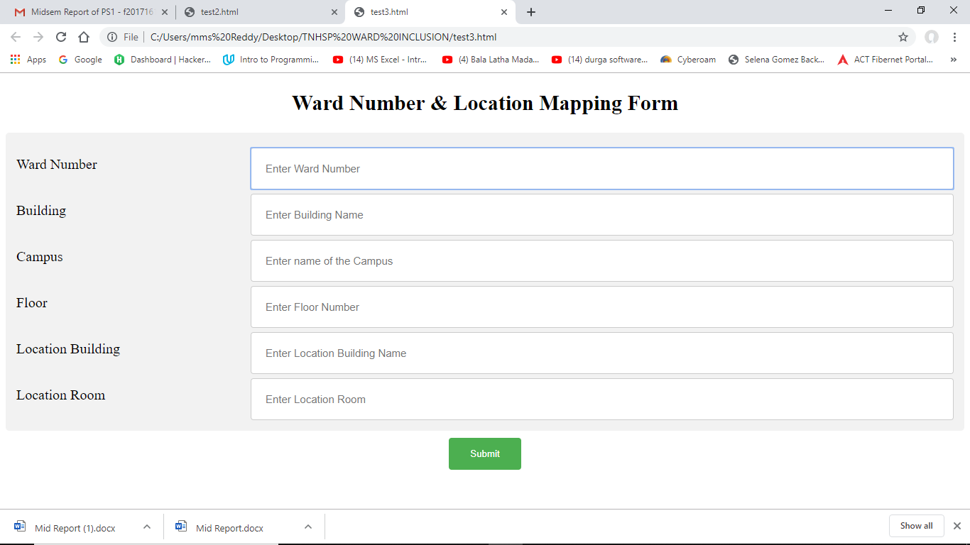

LEVEL 1

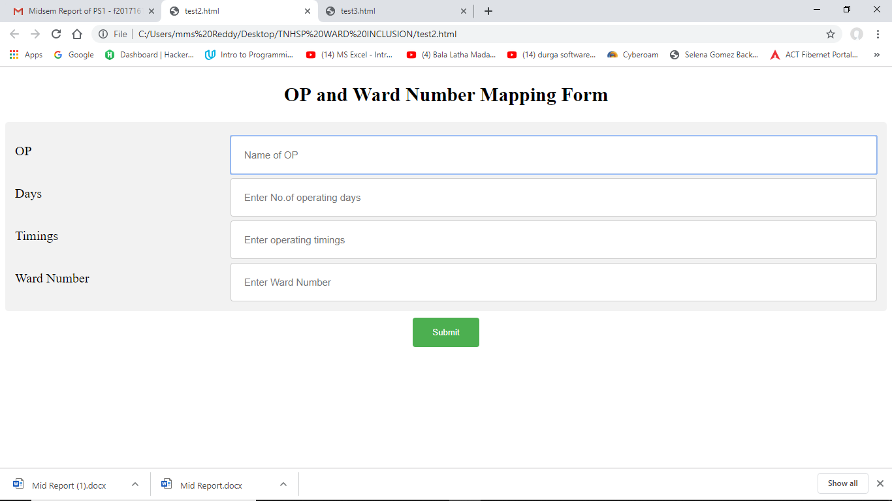

LEVEL 2

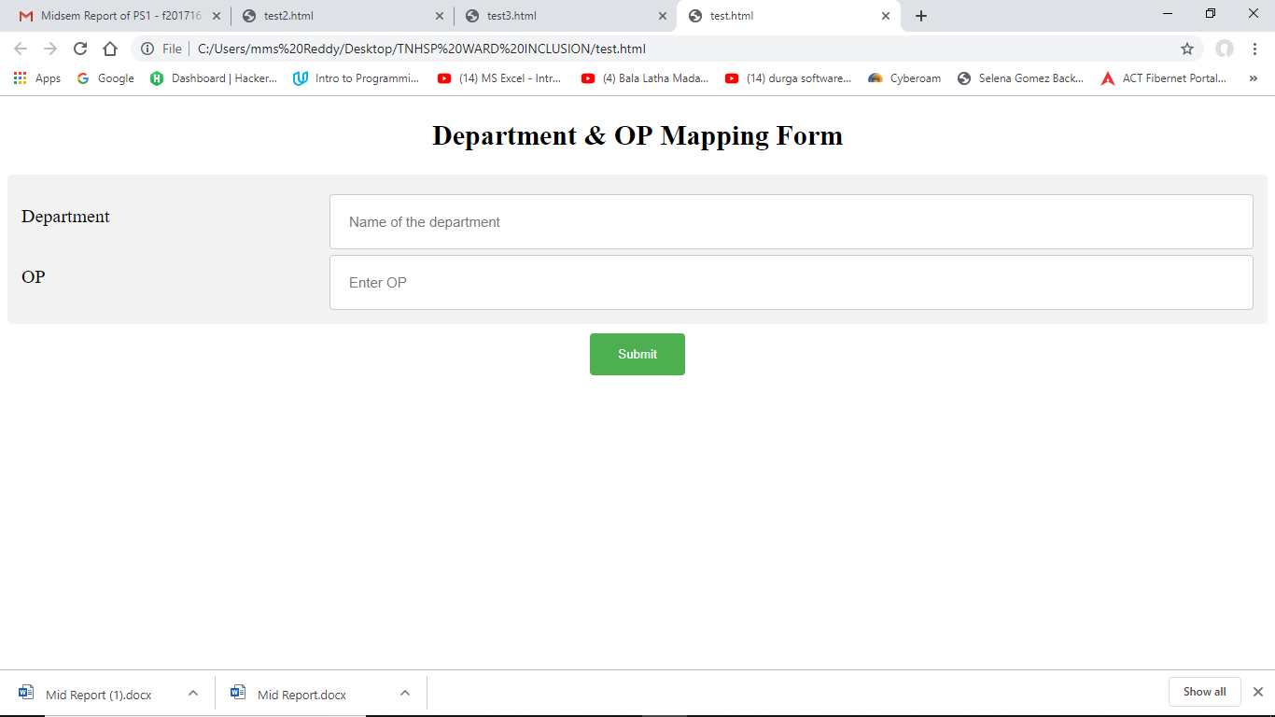

LEVEL3

The above three pictures describe about how we are able to take the data of three levels by using html forms. Here it takes the parameters that have to be stored into the database by input format i.e., the parameters which describe the location of the department i.e., the building in which it is located, the floor and the room numbers consisting the department, the ward numbers and op numbers, & also the timings at which the departments operate. Hence, the above three html forms are used for inserting the data about the department’s location into the database.

**FORMS USED FOR UPDATING DATA**

The forms used for updating the database also takes the same parameters but the submit button’s functionality is changed to update the existing data instead of inserting the data. We have considered updating the whole parameters even if there is change only in one parameter because by doing this the data will be made more accurate.For this we’ve taken measures that the form will only be submitted if the admin fills up all the fields.Even if one field is also empty, then it will display an error message using an alert box.

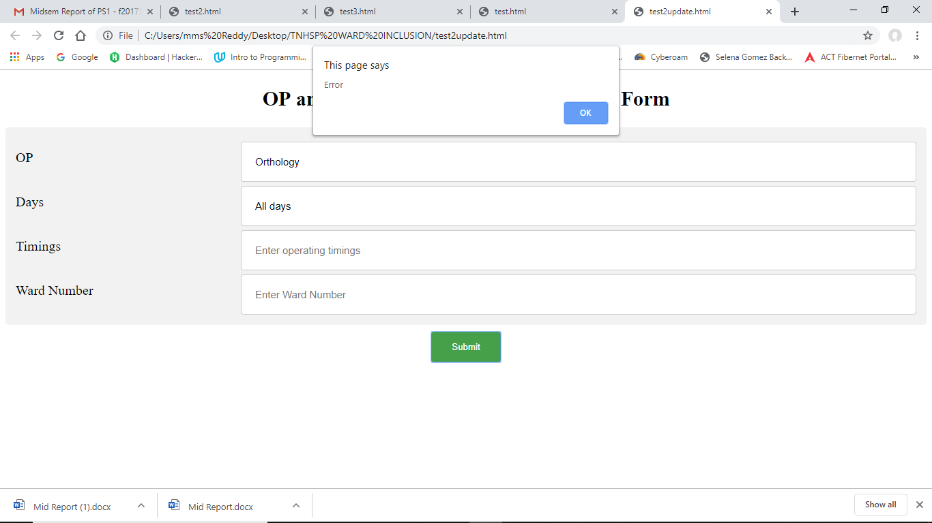

In the above picture we can see that I have only entered two parameters i.e., OP and days and pressed submit. But the form didn’t accept the data and has shown an error message. Hence, we’ve made restrictions to the admin to enter all the fields of the data even though the admin needs to update only a single field because it would ensure double verification.

**FORMS USED FOR REMOVING DATA**

For removing the contents in the database, the removing html forms are used

There are three levels of removing,

1. Removing the entire Ward or a particular unnecessary field of its location
2. Removing the entire OP or a particular unnecessary field of its operating details
3. Removing the entire Department

In all these three levels of forms the first field consists of the index or main field and the second field consists of the sub field which describes about the main field. A particular field is only removed if the admin enters that particular field and the main field in which it is present. If only the main field is entered and the sub field is left blank then the entire main field’s information is removed.

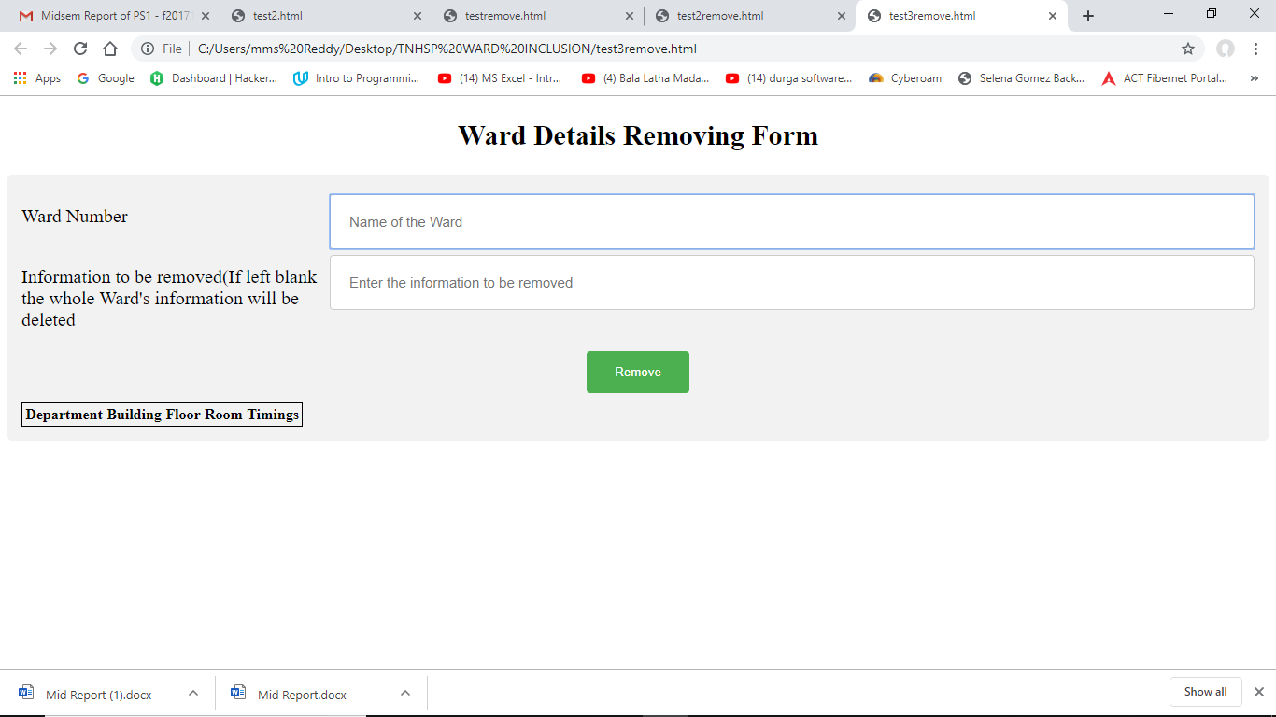

LEVEL 1

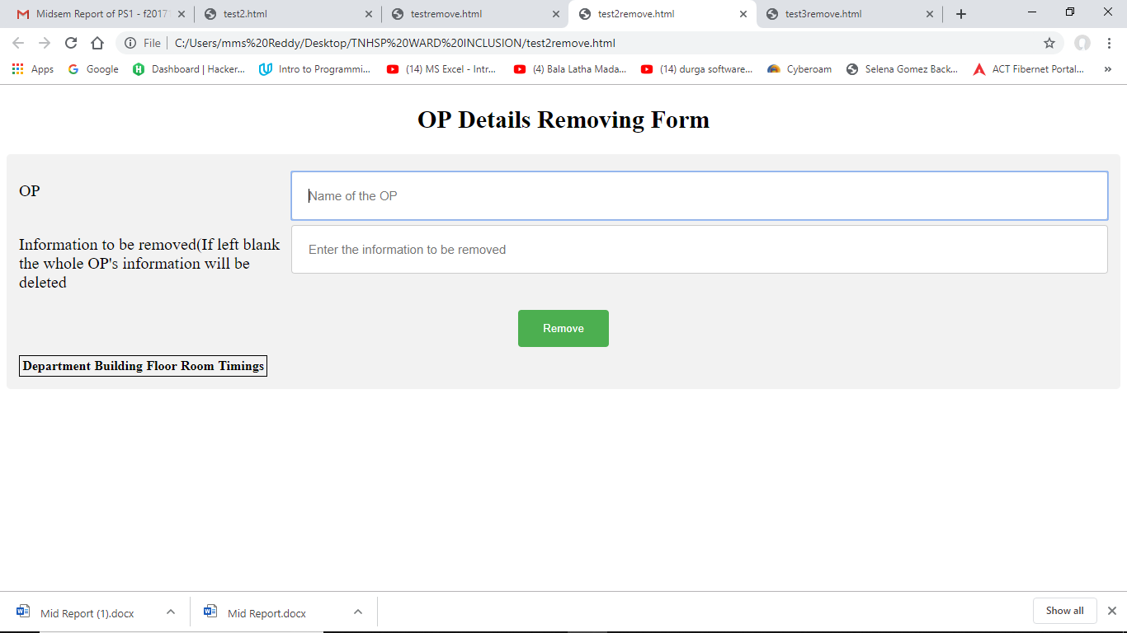

LEVEL 2

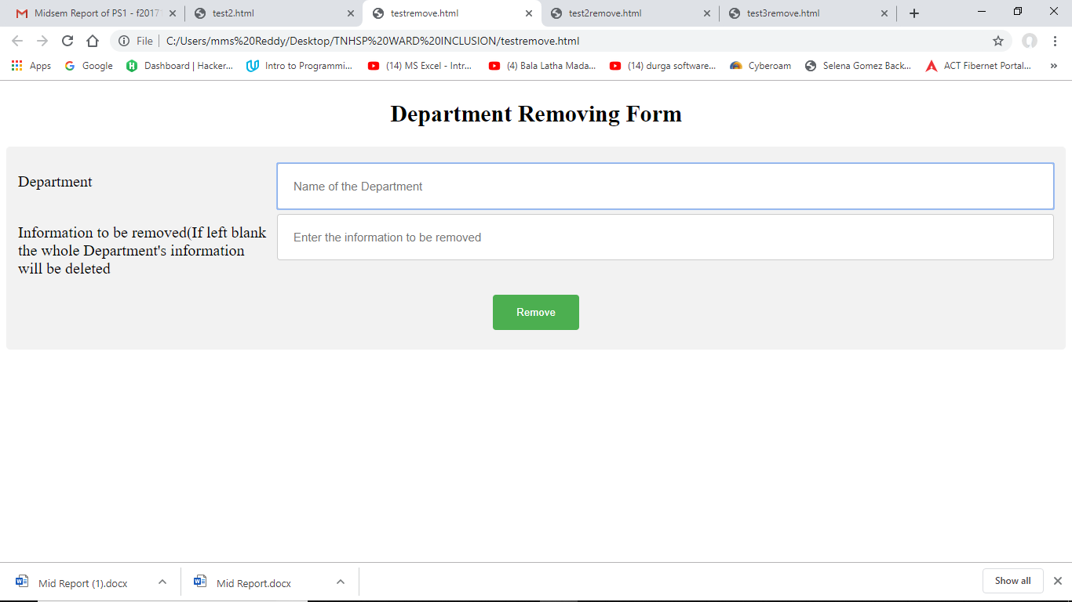

LEVEL 3

**SOFTWARES USED FOR CREATING THE WEBSITE’S**

**FRONT END**

For creating the front end of the website, we have used:

1. HTML for telling the browser about how to display the content of the website

2. HTML forms for displaying the input fields, taking them and storing it into a form.

3.CSS for styling up the webpage i.e., to setup the layout of the webpage.

## 3.CREATION OF ADMIN DASHBOARD

## 4.FIREBASE

The Firebase Realtime Database is a cloud-hosted database. Data is stored as JSON and synchronized in real time to every connected client. It is a NOSQL database which means that there is no restriction that data should only be stored in table format which can be differentiated with SQL database in which data can only be stored in table format.

We particularly preferred the usage of firebase database for our project because it can easily integrate and interact with web and voice-based applications which is the primary requirement of the project. And the integration process is also very simple in nature. All we have to do is just paste a snippet of code into our html file or java script file and firebase will take care of the rest.

### CODE SNIPPET

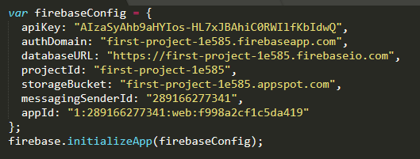

The above Snippet of code contains information (unique id) about the particular database in which information must be stored.

### SOURCES OF FIREBASE TOOLS



It provides all necessary tools for easy connectivity between the app and the database and we can access those tools by including the sources at which those tools are available inside our code. The code typed for including the tools into the website is shown in the above picture.

### HOW FIREBASE DATABASE LOOKS LIKE?

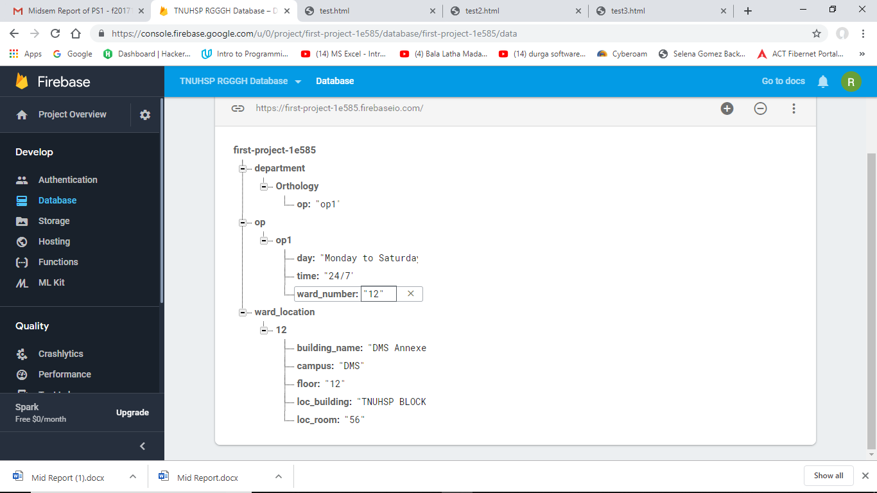

In the above picture we can see how information is stored inside the database.

We first define child’s which become the main nodes in the database & then we will map them with their sub nodes.

In our database we have used three different levels of mapping:

1. Mapping the Ward number with its respective location
2. Mapping the OP with its Ward numbers
3. Mapping the Department with its OP’s

By using three levels of mapping, modifying the data becomes much easier i.e., here the location of the ward has a very minimal chance of changing, hence by separating the location of the ward number from the department and op parameters makes modifying of the department and the op details much easier. We can explain the same thing for department and op’s also.

If we look once again into the picture, the information is stored in a key and value type of format (Key: Value). This particular type of format is called json format and we have used json format in our database because it is easier to access information.

## 4.LINKING DATABASE WITH WEBSITE

This part is simply the backend of the website we’ve designed. For this part the software we are using is:

1.JavaScript: We use JavaScript to program the behavior of the webpages. We define the functions each button performs in the website (insert, update& remove) using JavaScript and we use JavaScript to assign that particular function to that particular button. It is also used for establishing connection between firebase database and the website.

2.Firebase Database: We require the id of that particular database in which information should be stored. In firebase each database is assigned a unique id so that we can distinguish one database from other databases.

The procedure for linking up the website to the database is described in detail as follows:

1.We have to submit the form by defining new variables and assigning them with the values of the inputs the user has entered. All these operations can be executed at once by defining them inside a function

2.Then we need to point our website to that particular firebase database on which we want to store data by inserting a snippet of code into our html file or JavaScript file which consists the unique id assigned to that database.

3.For saving them onto firebase database we have to define the particular JSON format in which the variables should go into the database.

4.For reading the database values and for displaying them on the website we can include a table inside our website and then include a Jquery. The Jquery software is available on google and can be included into our html or JavaScript file by including the source(link) of that site at which the software is available.